CHARALAMPOS AND CLEAN MONDAY
A children’s story for young and old
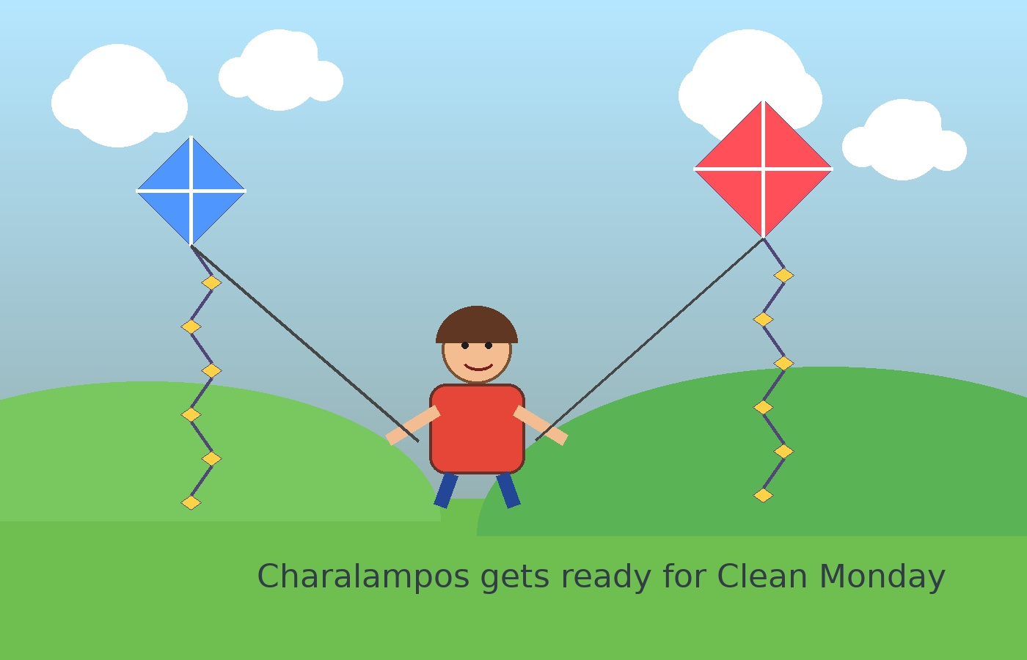
Pantelis Papakonstantinou
Books-4u Editions
2026

Copyright
This English edition is prepared for Kindle upload. The eBook cover is uploaded separately on Amazon KDP.
Author: Pantelis Papakonstantinou.
Publisher: Books-4u Editions.

Table of Contents
Dedication
Prologue
Charalampos and Clean Monday
Back Cover Text

Prologue
This story is part of a children’s series with the main title “Fairy Tales”, created to introduce children to the world of stories while combining knowledge with humor and the funny side of life.
In all these stories, the main hero is Charalampos, and his friends Lefteris and Panagiotis often take part in his adventures.
Each story includes a glossary of unfamiliar words, so that young children can understand the more difficult words they meet in the text.

Charalampos and Clean Monday
Charalampos woke up early in the morning with a big smile on his face.
It was not an ordinary morning.
It was Clean Monday, the day when the whole family went out into the countryside, flew kites, and celebrated the beginning of Lent.
“Mom! Are we going to fly the kite today?” he shouted impatiently.
“Of course!” his mother answered. “But first we have to prepare the basket with the fasting foods.”
The kitchen smelled wonderful. There was warm lagana bread, taramosalata, olives, stuffed vine leaves, and halva. Charalampos helped place everything carefully into the large wicker basket.
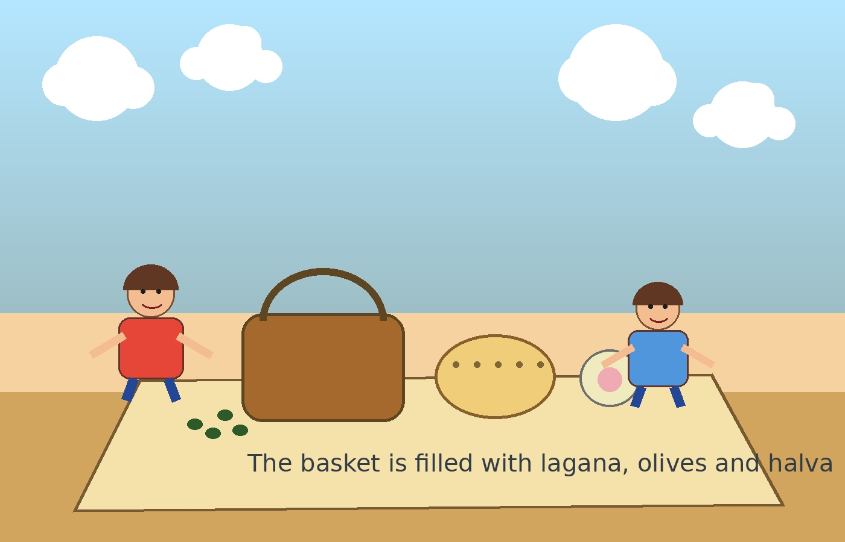
When they were ready, they went to the square and took the trolleybus to Zappeion, where the buses to Gerakas started their route.
After about an hour, the family reached their destination.
They got off, and Charalampos saw an endless meadow full of poppies. At one side of it there was a green hill. At the foot of the hill stood a small church with a large pine tree in its courtyard, and across from it there was a little tavern.
“This is Mr. Thanasis’s tavern,” his father said. “We will come here to eat after we finish flying the kite.”
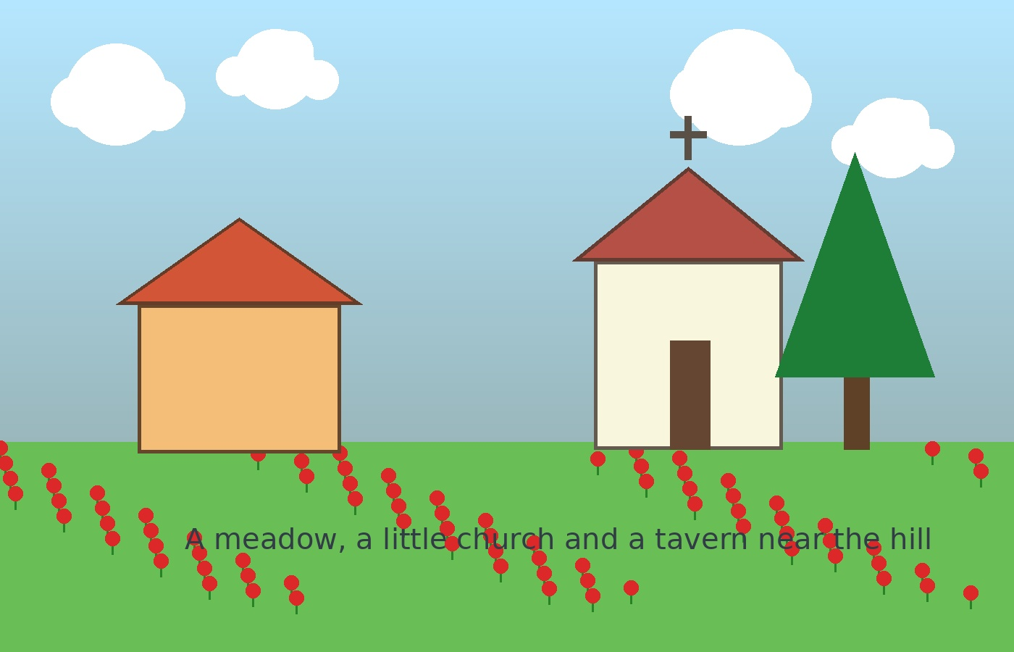
The parents of Lefteris and Panagiotis agreed, and they all walked together toward the hill.
See more in the book

